myFaves

Final Design Document

by

The Creeperssss

Andrew Jackson, Matthew Brannick, William Casey,
Josh DeVinney, T.J. Moats, Devin Mullenix,
Table of Contents
Preface: 3
Project Approach: 3
Task Delegation: 3
Tools and IDE’s Used: 3
Software Organization: 5
Software Architecture Diagram: 5
UML Diagrams: 6
Entity Relation Diagram: 6
Use Case Diagram: 6
Data Dictionary: 7
User Interface Mockups 9
Website: 9
Desktop: 10
Usability Metrics: 10
Usability Problem and Defect Management: 10
Screenshots of Functioning Product: 11
Web Application: 11
Desktop Application: 11
Stumbling Blocks and Setbacks: 11
Server & JavaScript Setbacks 11
Web Development Setbacks: 12
Desktop Client Setbacks: 12
Conclusions: 12
Additional Implementations: 12

Preface:
The goal of this project is to develop software that allows users to create playlists from a master list of songs and allow users to search the database of songs based on different criteria. Implementation must include a 3-tier software architecture solution including a database holding relevant data, a servlet to handle data retrieval and updates, and at least two user clients including, but not limited to a website application, a mobile application, or a desktop application. The database layer will be implemented in MySQL. The servlet will be in Java and use JDBC to connect to the database.

Project Approach:
To implement myFaves, we took a minimalist approach to software development. In the three tier software architecture design, we decided that there should only be one servlet to handle requests from each client’s platform, there should only be one server and that the front end GUI should be as consistent across platforms as possible.

Task Delegation:
To utilize each team member’s talents, we decided to split the group into different teams. Each team is responsible for one of the tiers involved in this project’s three tier architecture. There is a server team, a web team and a desktop team. The server side team’s responsibilities included setting up the mySQL database, running tomcat and tweaking the different connector classes. This team was also responsible for the operation of the Linux server that served as our host. The web development team was responsible for the creation of the myFaves website and the scripts associated with JavaScript and JSON. The Java team was tasked with creating the desktop client using JFrame.

Tools and IDE’s Used:
Considering the size and scope of this project, several third party tools were considered to ease development. For the conceptual stage, UML and software architecture diagrams were created using Software Ideas Modeler from softwareideas.net and Creately from creately.com. The team members responsible for diagramming used their preferred diagram modeling tools. This did not create problems as the finished diagrams were published as images and not software-specific file types.
During the programming process the server side, web development side and java side all used different Integrated Development Environments. The mySQL database was created in using the mySQL workbench from wb.mysql.com/. The mySQL workbench was chosen for this project because it offered functionality not present in the ubuntu g++ text editor. Workbench allowed us to check for errors and compare generated ER models to our conceptual ER models.
Adobe Dreamweaver CS5 was used to create the myFaves website. Dreamweaver was chosen because it allowed us to abstract away the difficulties in building a website from a blank text file; Dreamweaver made the editing of objects and fields dramatically easier than modifying tags line by line. The Firebug web development tool was especially helpful in debugging the various JavaScript methods of the myFaves website.
The Java and JavaScript files were developed in BlueJ from La Trobe University and in Eclipse, the open source project. BlueJ proved especially helpful in the fact that it allows developers to test individual methods even if the project is not completed or continues to experience compilation errors. For example, we were able to test several methods related to the display of song information which was retrieved from the server. Despite the fact that the mySQL connector was not completed, BlueJ was able to pass the methods test data allowing us to test its functionality before the connector classes were implemented.
Eclipse provided the same benefits as BlueJ, except for individual method testing. Eclipse is a useful tool in object oriented programming because it has an auto suggest tool for code completion. Basically, if one types a period at the end of an object, a drop down menu appears with all of the relevant methods related to it. This allowed the Java development team to save time when programming.
As for Source Control, we decided to use Git Bash and create a public repository on Github.com. Git proved to be a valuable tool for a project of this scale. Github made sharing and collaboration possible. Initially setup was difficult because of git and github’s various security requirements but there were few problems with the source control software after it was set up properly.

Software Organization:

Software Architecture Diagram:
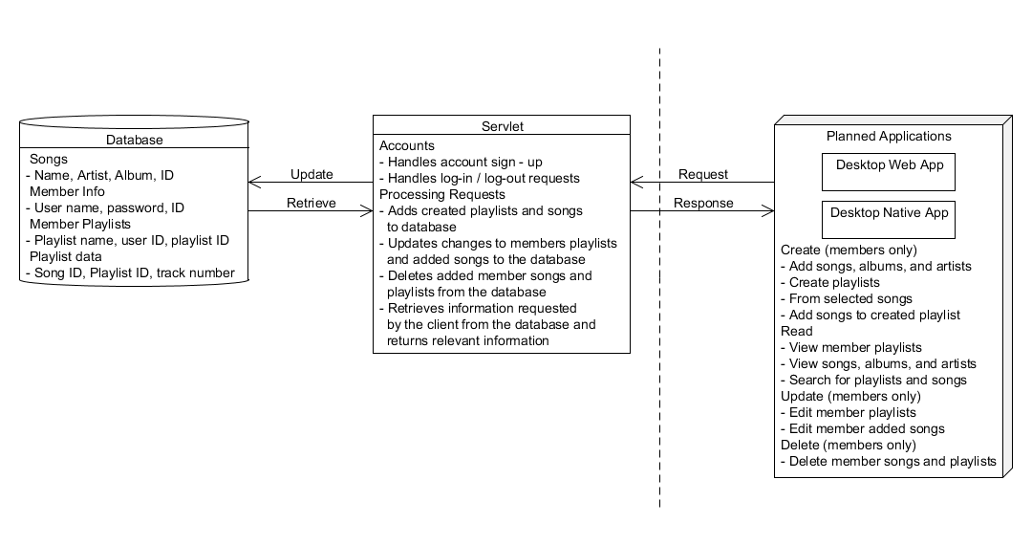
Shown above is our software architecture diagram. For this project, we decided to focus on creating a strong foundation of software on which we can expand later to increase functionality. The project detailed the requirements for a database, servlet, and two user applications, but allowed us to define the implementation.
The users and visitors of our application use either a web-based desktop application or a native desktop application to request information about the database from the servlet. The web app will be based on HTML with Javascript AJAX functionality and CSS for look-and-feel. The native desktop app will be programmed in Java using the Java Swing libraries. The clients will allow users to log-in, search and browse available songs and member playlists, and create new playlists if they are signed in. All requests will be in HTTP form.
A single servlet will handle the clients’ request; it will respond to the client with the appropriate response and, if required, will execute MySQL commands to interact with the database, retrieving, adding, and updating data. Responses to the client will be in HTML form with JSON implemented as needed for requested information.
The database will hold all relevant information about the software solution. It contains information about each song, playlist, and member. The specific design of the database is detailed later in this report.

UML Diagrams:

Entity Relation Diagram:
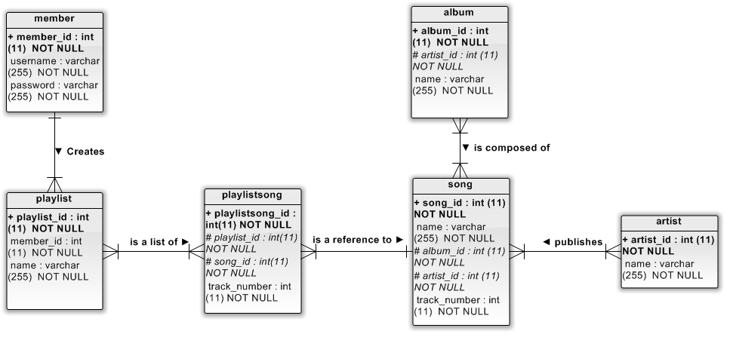

Use Case Diagram:
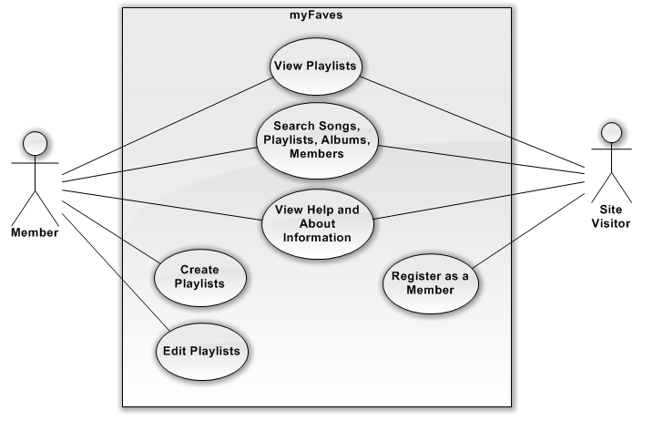

Data Dictionary:

Description of Entities
Entity Name | Description | Aliases | Occurrence
artist | The term for a composer/ performer of a song or groups of songs in the case of an album |  | A performer is responsible for composing one or many songs and/or albums
album | A collection of songs released under the same label |  | An album has from one to many songs contained in it.
member | A user to the website/application |  | Each member can create many playlists or none.
playlist | A collection of assorted tracks chosen by the user |  | Each member can have no playlists or as many as they want.
song | A song is an object that is made/belongs to an album and an artist |  | Each song can be released under different albums but it cannot be released twice in the same album.
playlistsong | An instance of a song found in a user’s playlist |  | Each playlist can have one to many references songs

Description of Attributes
Entity Name | Attributes | Description | Data Type & Length | Nulls | Multi-Valued
artist | artist_id | uniquely identifies an artist | 11 digit integer | no | no
artist | name | artist  the artist’s name | 255 variable characters | no | no
album | album_id | uniquely identifies an album | 11 digit integer | no | no
album | artist_id | uniquely identifies an artist | 11 digit integer | no | no
album | name | the name of the album | 255 variable characters | no | no
member | member_id | the unique identifier of a member | 11 digit integer | no | no
member | username | the member’s desired username | 255 variable characters | no | no
member | password | the members desired password | 255 variable characters | no | no
playlist | playlist_id | the playlist’s unique identifier | 11 digit integer | no | no
playlist | member_id | the member’s unique identifier | 11 digit integer | no | no
playlist | name | the playlists name | 255 variable characters | no | no
song | song_id | the unique identifier of the song | 11 digit integer | no | no
song | name | the title of the song | 255 variable characters | no | no
song | album_id | the unique identifier of the album | 11 digit integer | no | no
song | artist_id | the unique identifier of the artist | 11 digit integer | no | no
song | track_number | the unique identifier of the song | 11 digit integer | no | no
playlistsong | playlistsong_id | the unique identifier of the playlist song | 11 digit integer | no | no
playlistsong | playlist_id | the unique identifier of the playlist | 11 digit integer | no | no
playlistsong | song_id | the unique identifier of the song | 11 digit integer | no | no
playlistsong | track_number | the unique identifier of the song’s track number | 11 digit integer | no | no

Description of Relationships
Entity Name | Multiplicity | Relationship | Multiplicity | Entity Name
artist | 1..* | composes | 1..* | song
artist | 1..* | has an | 1..* | album
album | 1..* | is composed of | 1..* | songs
album | 1..* | is made by | 1..* | artist
member | 1..1 | makes a | 1..* | playlist
member | 1..1 | adds a | 1..* | song
playlist | 0..* | contains | 1..* | song
playlist | 0..* | is owned by | 1..1 | member
song | 1..* | is composed by | 1..1 | artist
song | 1..* | is part of | 1..* | album
playlistsong | 1..* | is a reference to | 1..1 | song

User Interface Mockups
Website:
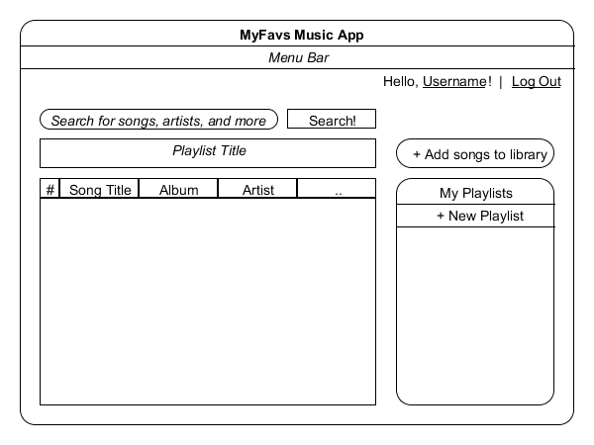

Desktop:
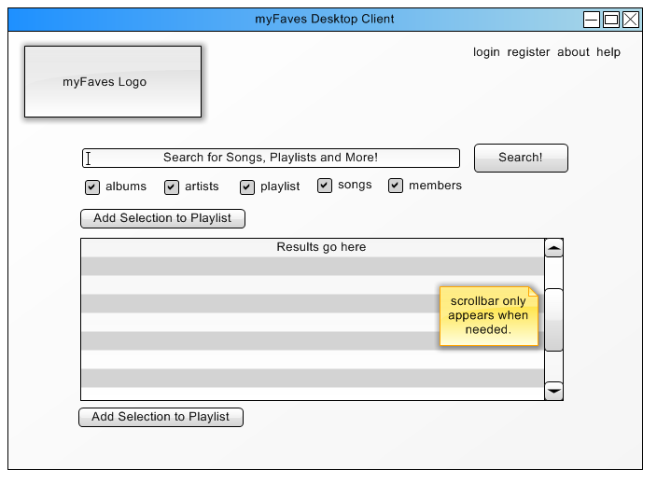
The figure above is a prototype of our intended design for our desktop application. Aiming for a simplistic approach, there is only one main window from which all can be accessed. Logging in is handled by a simple dialog when “Log-in” is clicked on the top right of the window. Once a user is logged in, the button switches to log out and welcomes the user.
The main feature will be the search bar which will allow the user to search for any song, playlist, or other member and display the info in the table below. The table will have customizable columns based on attributes like song name, album, artists, and are alphanumerically sort able depending on the chosen column.

Usability Metrics:
survey and responses/recommendations

Usability Problem and Defect Management:
MyFaves was designed to gracefully recover from errors during runtime. The Java and JavaScript programs all implement try, catch and finally blocks of code to handle exceptions. In the web development area, firebug was used to find common errors and address them before publication.

Screenshots of Functioning Product:

Web Application:

x Home

x Search

x Playlist?

Desktop Application:
x Home

x Search

x Playlist?

Stumbling Blocks and Setbacks:
Server & JavaScript Setbacks:
While trying to get the java server up and running, we encountered several problems with the Tomcat setup. No one had ever written code for a tomcat server, nor did we know which parameters to use when compiling the code. In the end this was remedied with a regular expression based compile to grab the libraries that were used in the project.
Another pitfall we encountered was the creation of the cookies by the tomcat installation. Because of the way tomcat handled the cookies we were unable to specify our own parameters for them, thus we had no way of handling the cookies client side you can’t set a cookie before you connect in the default java api http connector. To remedy this we decided to use apache’s http connector class.

Web Development Setbacks:
The development of the myFaves website went much more smoothly than in the other areas of this project. That being said, there were still several problems relating to browser compatibility and JavaScript functionality.

Desktop Client Setbacks:
Several setbacks were overcome in the course of developing the desktop interface of myFaves. The exact placement of JFrame objects such as text fields, buttons and textboxes was time consuming but not especially difficult; the look of the desktop application had to closely resemble the document object model of the myFaves website. Code wise, JTable proved especially temperamental. JCheckBoxes in the select songs column was especially difficult and time consuming to implement.

Conclusions:
tomcat sucks kcid.

Additional Implementations:
Given more time to develop myFaves, there are several additions we would implement.

